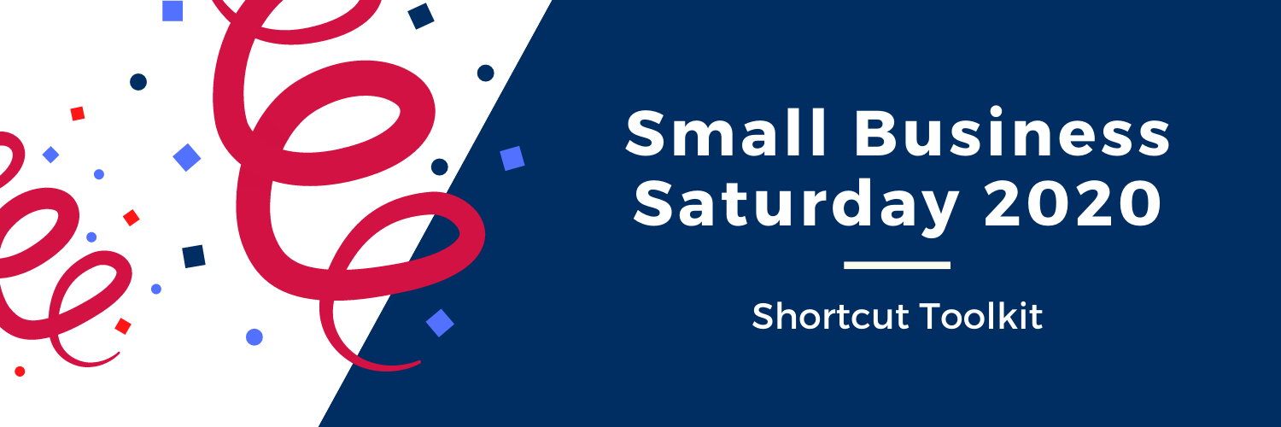

Small Business Saturday 2020 is right around the corner! We encourage you to utilize this shortcut toolkit to stand out amongst the crowd and have a successful Small Business Saturday.
Tips
- Touch up your website and social media. Make sure that all of your information on your website and social media is up to date and accurate. Often times your social media platforms like Instagram can become cluttered overtime, therefor you may want to clear out unwanted content and information.
- Promote on social media. Promote Small Business Saturday using #ShopSmall across all social media platforms. Also, encourage customers to take a selfie at your shop and tag your business.
- Plan an event on Small Business Saturday. Organize an event including promotions, discounts, coffee bar, free gifts, etc. This will give customers an incentive to come to your store and shop on that Saturday.
- Partner with other small business owners. Contact other small businesses in your area and team up to provide special discounts, promotions, or even donations for a local charity.
- Extend business hours. Staying open later and opening earlier for the day of Small Business Saturday could have a great impact on sales.
How to set yourself apart
- Provide an online option. Giving customers the opportunity to shop safely online can increase sales. Also offering free shipping on Small Business Saturday is a great way to increase traffic.
- Offer wrapping and delivery services. Providing customers with personal incentives will set yourself apart.
- Share your COVID-19 safety precautions. Think about how you are going to provide a safe environment for all of your customers.

Shop Small Studio American Express
Visit this link for easily customizable materials->
https://www.americanexpress.com/us/small-business/shop-small/studio/

Hashtags
#ShopSmall

Tag @wtsbdc in your social media posts and we will repost!

